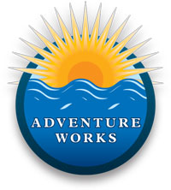

**Vision Benefits**

Toshiba offered their new miniature nuclear reactor to the small Alaskan village of Galena back in 2003, and after much deliberation it looks like the project is finally moving forward. The city council has voted unanimously to allow construction of the reactor, which Toshiba calls the 4S ("Super-Safe, Small, and Simple"—see how reassuring that is?), and if the Nuclear Regulatory Commission approves, it could be up and running by 2010. The Galena reactor would be the first built in the US since the 1980's, when that little faux pas at Chernobyl had everyone ducking and covering under their school desks.

The 4S reactor will be the smallest reactor ever built, measuring about the size of a large spruce tree. The reactor core itself will be underground and encased in a concrete housing, making it "as safe from immune to attack or theft as a missle in its silo," according to Toshiba reps. Nice analogy, guys. The village of 700 will only have to pay for the reactor's operational costs, making the 4S not only a clean but cheap alternative power source that even some environment groups can (cautiously) get behind.

Coverage:

|  |  |  |  |
| --- | --- | --- | --- |
| Option 1 | Option 2 | Option 3 | Option 4 |
| Glasses | 90% | 80% | 50% |
| Contacts | 90% | 80% | 50% |
| Exams | 100% | 90% | 75% |